# **Block Cipher Primitives: Confusion and Diffusion**

Let's break down these two key ideas from Claude Shannon that are essential for strong encryption algorithms, especially block ciphers like DES and AES.

## **1. Confusion**

* **Definition:** Confusion is about making the relationship between the encryption key and the ciphertext (the encrypted output) as complicated as possible. The goal is to make it very hard for an attacker to figure out the key, even if they have the ciphertext.
* **How is it achieved?**
* The most common way is **substitution**: replacing parts of the data with other values according to a rule or table (like S-boxes in DES and AES).
* In DES, the S-boxes take bits and substitute them with other bits in a non-linear way.
* **Why is it important?**
* If you change just one bit of the key, confusion ensures that many bits of the ciphertext will change unpredictably.
* This makes it very hard to guess the key by looking at patterns in the ciphertext.

## **2. Diffusion**

* **Definition:** Diffusion is about spreading out the influence of each bit of the plaintext (the original message) over many bits of the ciphertext. The goal is to hide any patterns or statistical properties of the plaintext.
* **How is it achieved?**
* The most common way is **permutation**: rearranging the bits in a block according to a fixed pattern.
* In DES, bit permutation is used in several steps to mix up the bits.
* In AES, a more advanced operation called MixColumns is used for diffusion.
* **Why is it important?**
* If you change just one bit of the plaintext, diffusion ensures that (statistically) about half the bits in the ciphertext will change.
* This makes it very hard for an attacker to find patterns that could reveal the original message.

## **Why Both Are Needed**

* **Confusion alone** (like simple substitution ciphers) is not enough: attackers can still find patterns in the plaintext.

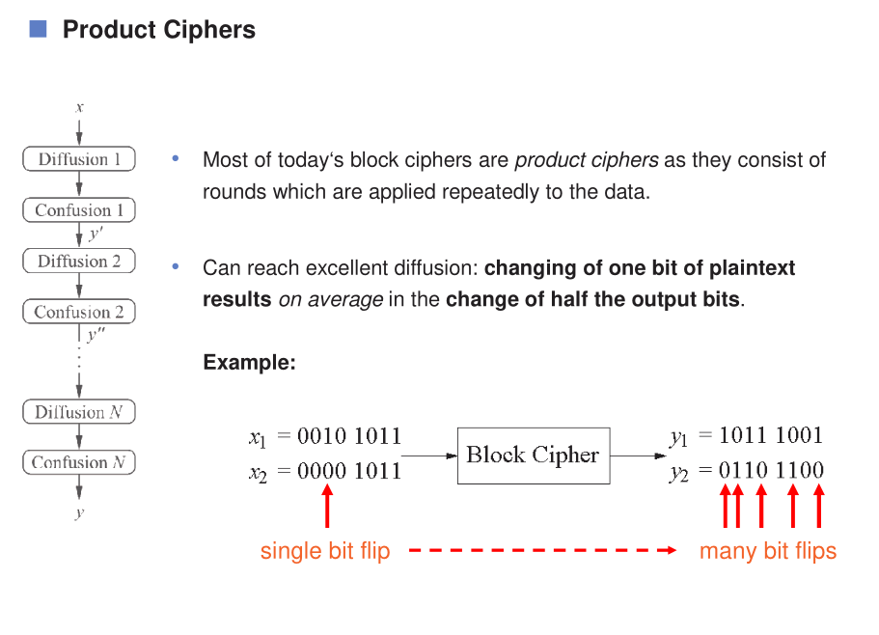

* **Diffusion alone** (like simple transposition ciphers) is not enough: attackers can still find relationships between the key and ciphertext.
* **Combining both** in multiple rounds (as in DES and AES) creates a **product cipher**—a strong cipher that is much harder to break.

## **Product Ciphers**

* **Product cipher**: A cipher that applies confusion and diffusion operations in several rounds.
* In each round, the data is substituted (confusion) and permuted (diffusion).
* After several rounds, changing one bit of input (plaintext or key) will change many bits of output (ciphertext), making the cipher secure against many types of attacks.

## **Quick Table: Confusion vs. Diffusion**

|  |  |  |
| --- | --- | --- |
| **Feature** | **Confusion (Substitution)** | **Diffusion (Permutation)** |
| Purpose | Hide key-ciphertext link | Hide plaintext-ciphertext link |
| Example | S-box in DES/AES | Bit permutation in DES |
| Effect | Key change affects many ciphertext bits | Plaintext change affects many ciphertext bits |
| Used in | Block & stream ciphers | Block ciphers only |

## **Summary**

* **Confusion**: Makes it hard to see how the key affects the ciphertext (usually by substitution).
* **Diffusion**: Spreads out the effect of each plaintext bit over the ciphertext (usually by permutation).
* **Product ciphers** like DES and AES use both, in multiple rounds, to achieve strong security.

If you want to see a simple example or have questions about any term (like S-box, permutation, round, etc.), let me know and I'll explain with visuals or step-by-step examples!

# 

# **DES (Data Encryption Standard) – Full Details**

Let's break down DES step by step, explaining every important term and process in detail. If you get stuck on any word or concept, let me know and I'll clarify further!

## **1. What is DES?**

* **DES** is a symmetric-key block cipher algorithm for encrypting digital data. That means: the same key is used for both encryption and decryption.
* It was developed in the 1970s by IBM and standardized in 1977.
* DES works on **64-bit blocks** of data and uses a **56-bit key** (even though the input key is 64 bits, 8 bits are just for error checking and not used for security).

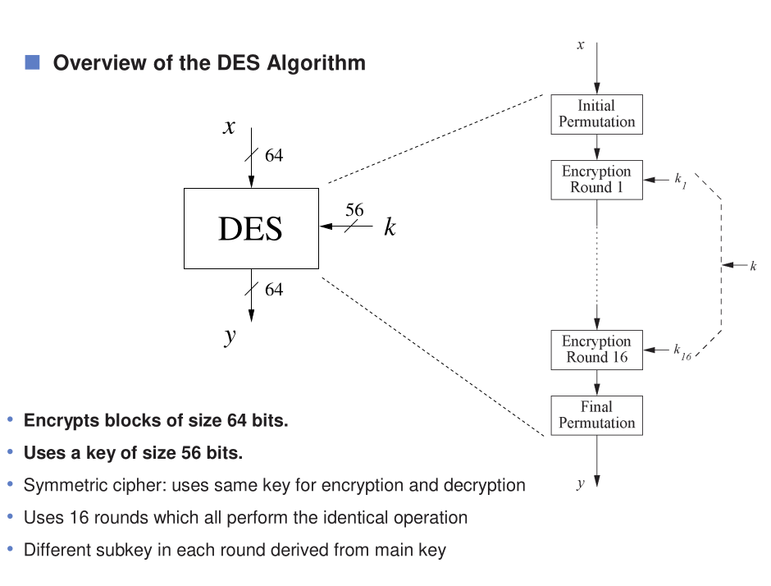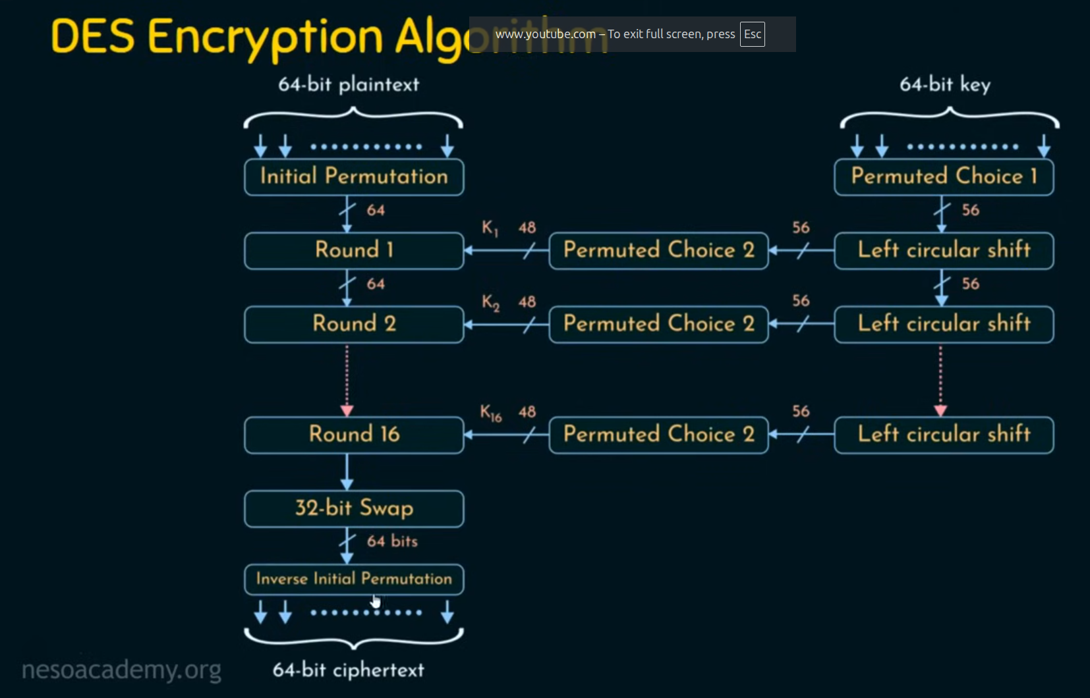

## **2. Key Terms Explained**

## **Block Cipher**

* DES encrypts data in fixed-size chunks (blocks) of 64 bits. Each block is processed separately.

## **Symmetric Encryption**

* The same key is used for both encrypting and decrypting data. If you have the key, you can reverse the process.

## **Key Length**

* DES uses a 56-bit key for security. The original key is 64 bits, but 8 bits are used for parity (error checking), so only 56 bits actually protect your data.

## **Feistel Network**

* DES uses a structure called a Feistel network. This means:
* Each block is split into two halves: Left (L) and Right (R).
* The algorithm runs for **16 rounds**. In each round, the halves are processed and swapped in a specific way.

## **Permutation and Substitution**

* **Permutation**: Rearranging the order of bits.
* **Substitution**: Replacing bits with other bits using a lookup table (S-box).
* These steps help hide patterns in the data, making it hard to break the encryption.

## **3. How DES Works – Step by Step**

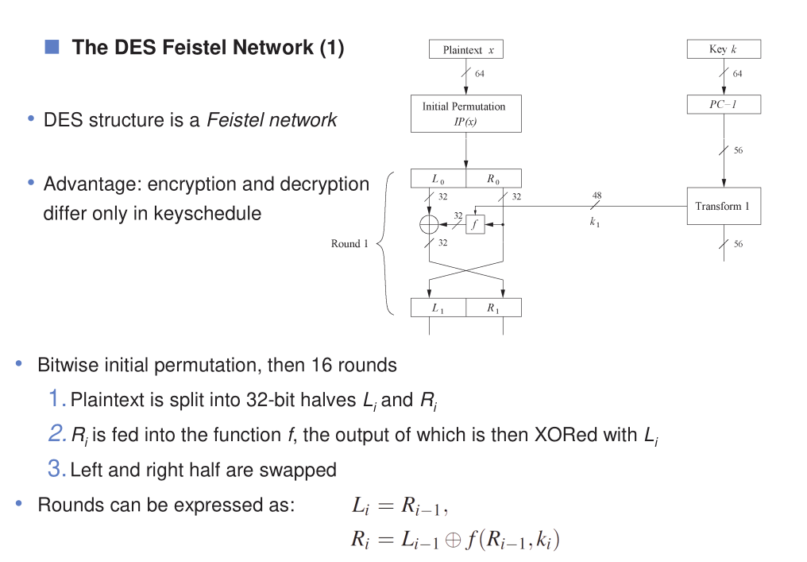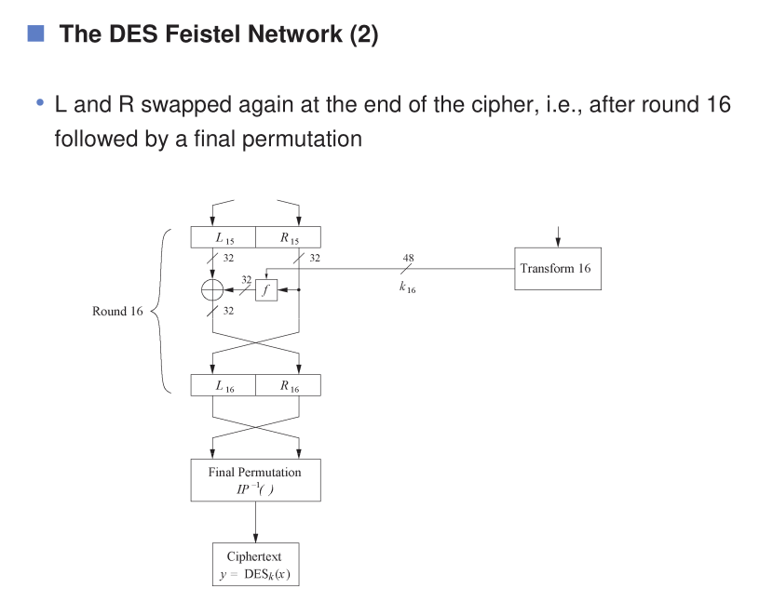

## **Step 1: Initial Permutation (IP)**

* The 64-bit block of plaintext is rearranged according to a fixed table. This spreads out the bits for better security.

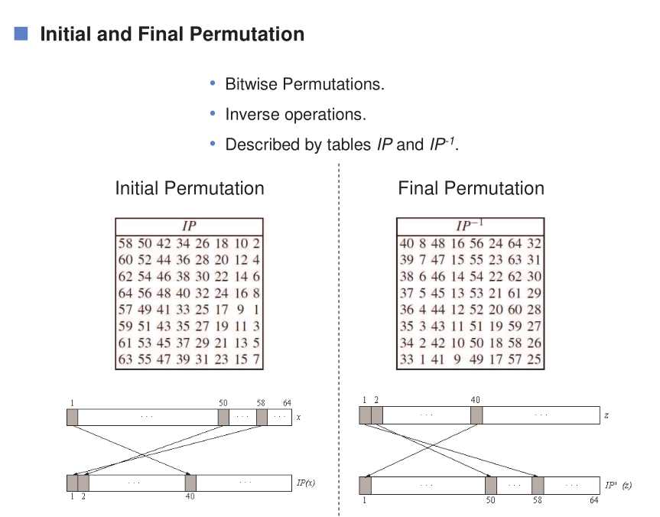

## **Step 2: Splitting the Block**

* The permuted block is split into two 32-bit halves: Left (L0) and Right (R0).

## **Step 3: 16 Rounds of Processing**

For each round (1 to 16):

1. **Key Schedule**: A different 48-bit subkey is generated from the main key for each round.
2. **Feistel Function (f)**: The right half (R) is processed:

* **Expansion (E)**: R is expanded from 32 to 48 bits.
* **Key Mixing**: The expanded R is XORed with the round subkey.
* **Substitution (S-boxes)**: The result is split into 8 groups of 6 bits, each passed through an S-box (a lookup table) to produce 4 bits per group (total 32 bits).
* **Permutation (P)**: The 32 bits are rearranged according to a fixed table.

1. **XOR and Swap**: The output of f is XORed with the left half (L), and then the halves are swapped for the next round.

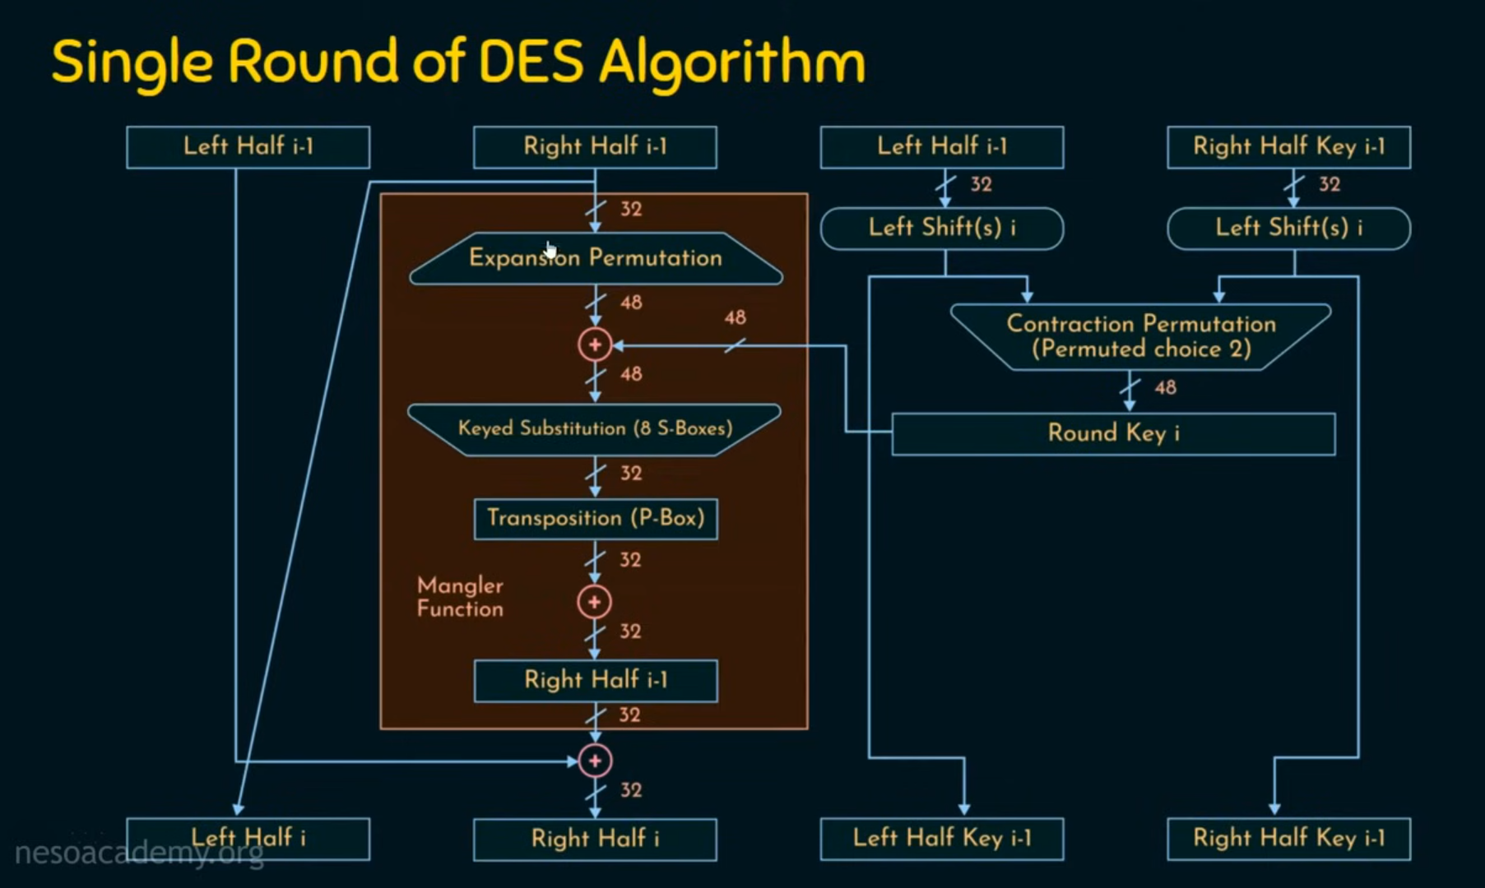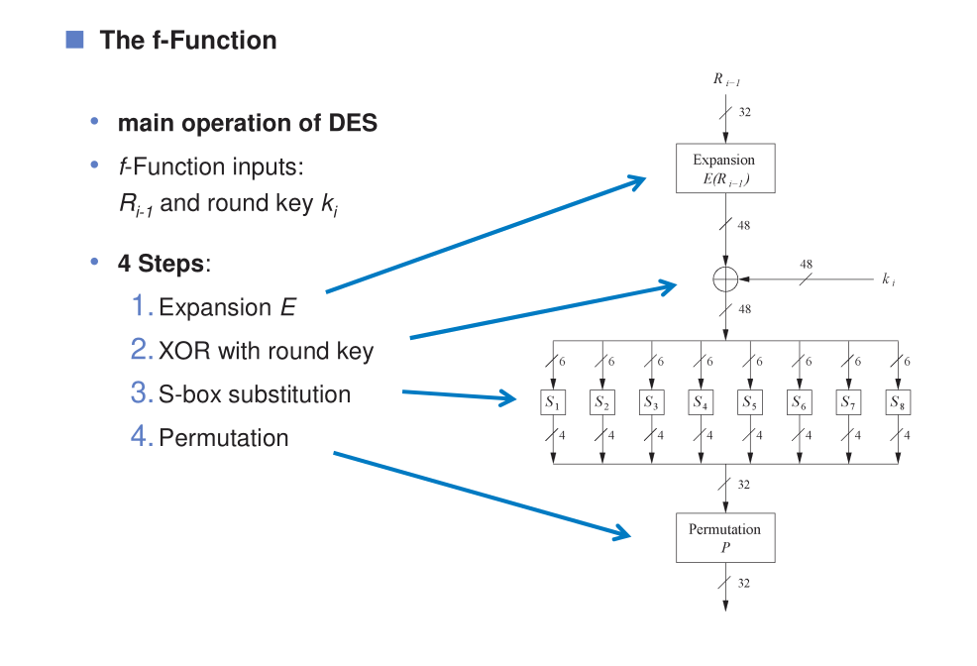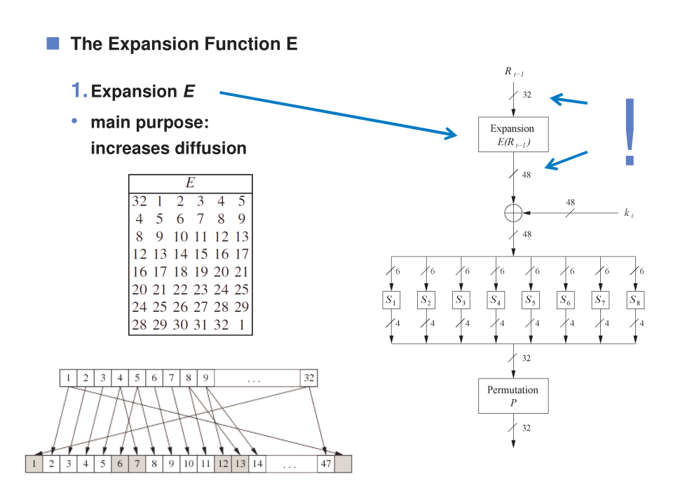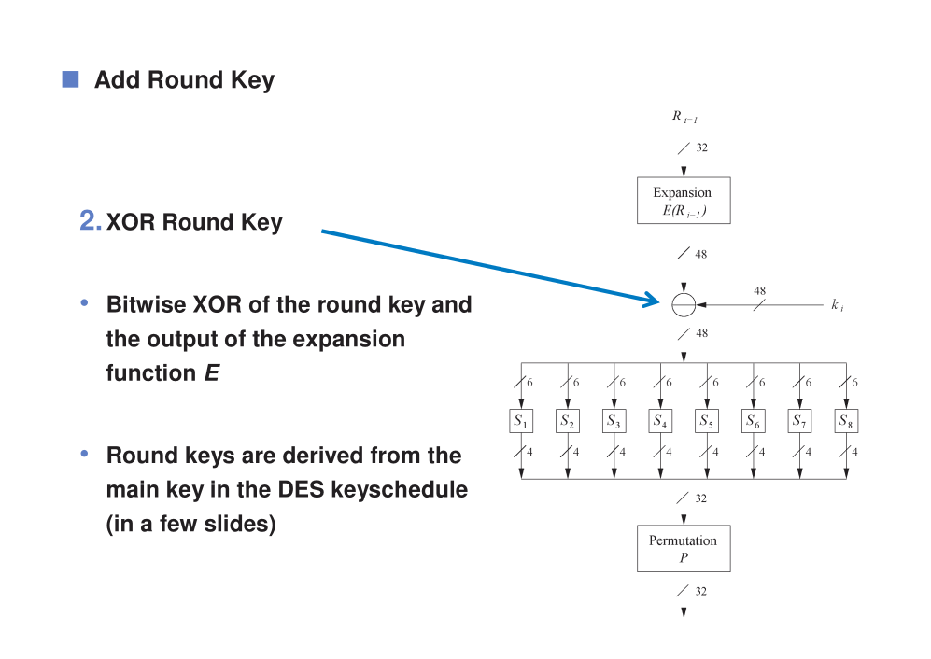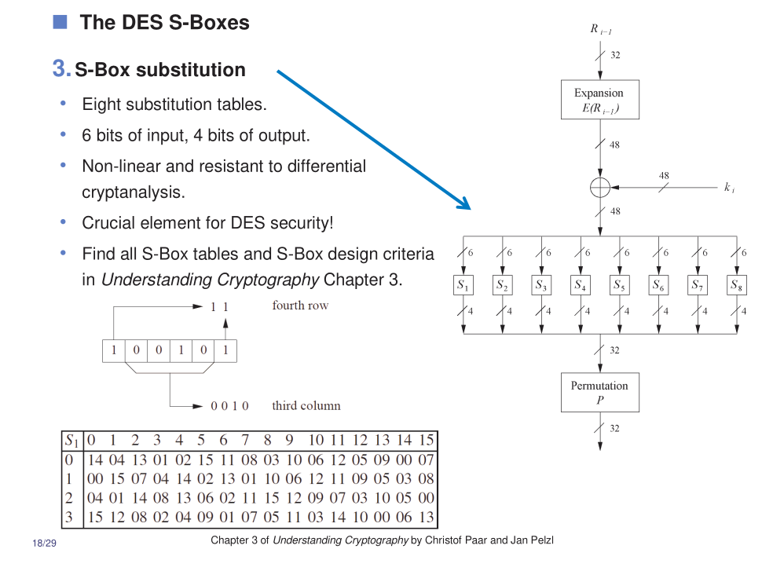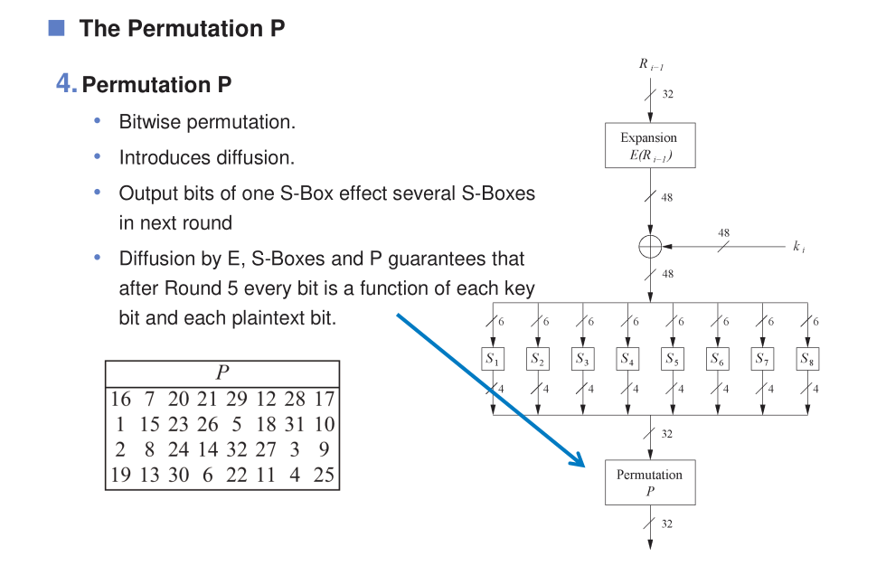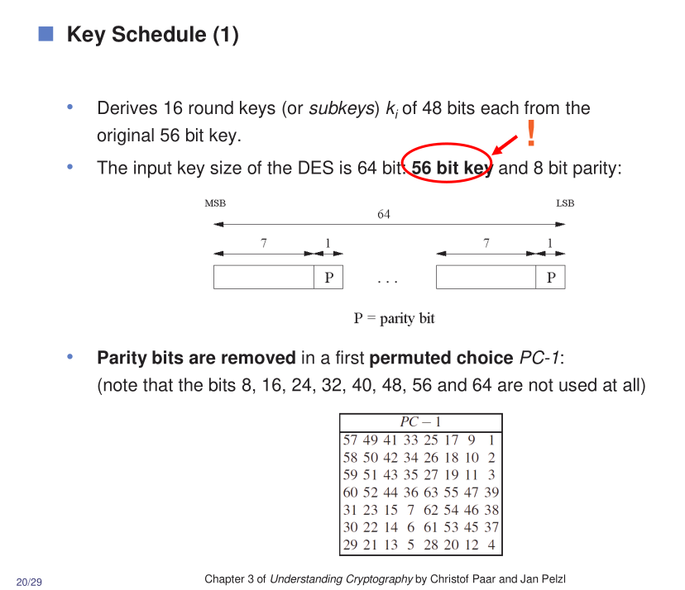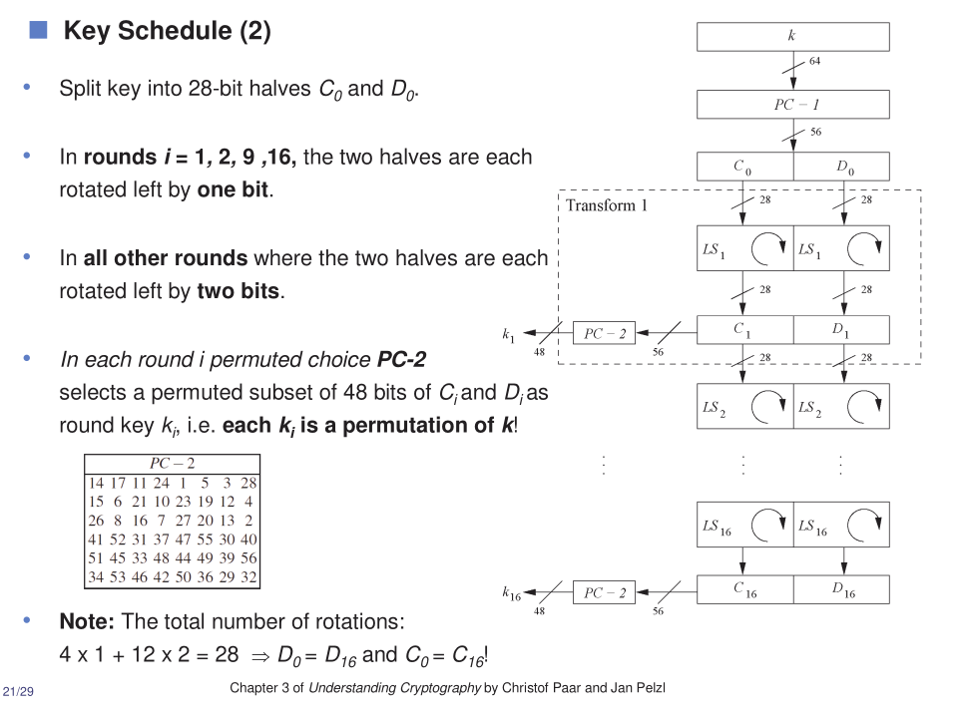

## **Step 4: Final Permutation (IP⁻¹)**

* After 16 rounds, the halves are combined and rearranged again using the inverse of the initial permutation table.
* The result is the ciphertext (encrypted data).

## **4. Key Schedule – How Subkeys Are Made**

* The original 56-bit key is split into two halves.
* For each round, both halves are shifted left (rotated), and then 48 bits are selected from the combined halves using a fixed table.
* This process creates a unique subkey for each round.

## **5. Decryption**

* Decryption uses the same process as encryption, but the subkeys are applied in reverse order (from round 16 to round 1).
* This is possible because of the Feistel structure.

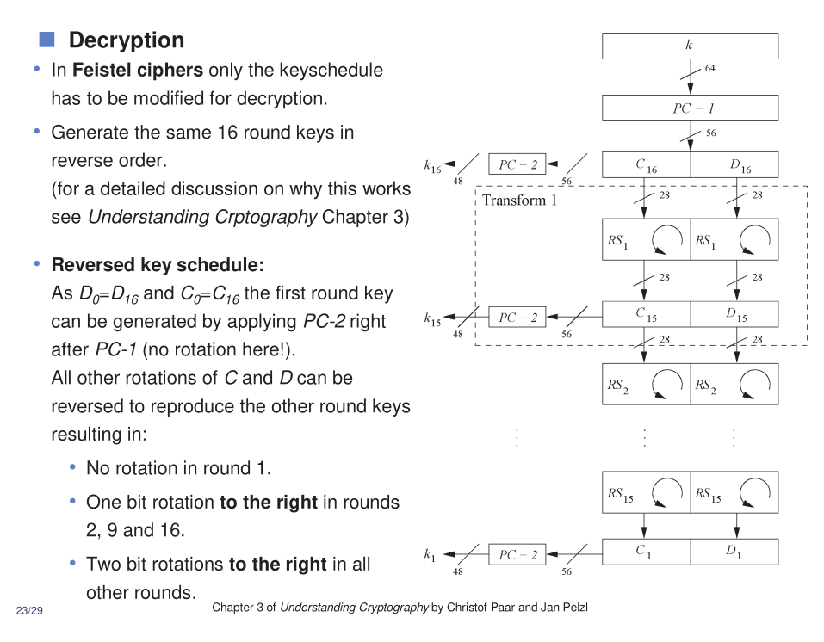

## **6. Why DES Is No Longer Secure**

* The 56-bit key is too short for modern computers. Brute-force attacks (trying every possible key) are now practical.
* DES has been replaced by more secure algorithms like **AES** (Advanced Encryption Standard).
* **Triple DES (3DES)**: To improve security, DES can be applied three times with different keys, making brute-force much harder.

## **7. DES Variants**

* **Triple DES (3DES)**: Encrypts data three times with two or three keys. Much more secure, but slower.
* **DESX**: Adds extra steps to make DES harder to break, but still not as secure as AES.

## **8. Where DES Was Used**

* **Data Transmission**: Securing data sent over networks.
* **Data Storage**: Protecting files and databases.
* **Authentication**: Verifying passwords and credentials.

## **9. Common Confusing Terms (Quick Glossary)**

* **Cipher**: An algorithm for encrypting or decrypting data.
* **Plaintext**: The original, readable data.
* **Ciphertext**: The encrypted, unreadable data.
* **Key**: A secret value used to encrypt/decrypt data.
* **XOR (Exclusive OR)**: A logical operation used to mix data and keys.
* **S-box**: A substitution box; a table that replaces input bits with output bits in a non-linear way.
* **Permutation Table**: A fixed table that tells how to rearrange bits.

## **10. Summary Table: DES at a Glance**

|  |  |
| --- | --- |
| **Feature** | **Value/Description** |
| Block Size | 64 bits |
| Key Size | 56 bits (actual) |
| Rounds | 16 |
| Structure | Feistel Network |
| Main Steps | Permutation, Substitution |
| Secure Today? | No (key too short) |
| Successor | AES, Triple DES |

## **11. Why Learn DES?**

* DES is a classic example of how symmetric encryption works.
* It teaches important concepts: block ciphers, Feistel networks, permutations, substitutions, and key schedules.
* Even though it's outdated, understanding DES helps you learn modern cryptography.

**If you want to see visual step-by-step explanations in Bangla, check out these YouTube tutorials:**

* [DES Algorithm Bangla Explanation]​
* [DES Round Key Generator Bangla]​
* [DES Function Bangla]​

Let me know which part you want to dive deeper into, or if you want a worked example with actual bits and keys!

## **What is Triple DES?**

Triple DES applies the DES algorithm three times to each data block. Instead of using a single 56-bit key, 3DES uses either two or three separate DES keys, effectively increasing the key length and making brute-force attacks much more difficult.​​

## **How Triple DES Works**

* **Encryption Process:** The plaintext is encrypted with the first key, decrypted with the second key, and then encrypted again with the third key. This sequence is often called Encrypt-Decrypt-Encrypt (EDE).
* **Keying Options:**
* **Three-key 3DES:** Uses three independent 56-bit keys (total 168 bits).
* **Two-key 3DES:** Uses two keys, where the first and third keys are the same (total 112 bits).
* **Decryption:** The process is reversed—decrypt with the third key, encrypt with the second, and decrypt with the first.

## **Why Triple DES?**

* **Security:** Standard DES is vulnerable to brute-force attacks due to its 56-bit key. Triple DES increases the effective key length, making such attacks impractical with current technology.​​
* **Compatibility:** 3DES is backward compatible with DES, allowing older systems to upgrade security without major changes.
* **Usage:** Still used in many legacy systems, especially in banking, though it is being replaced by more modern algorithms like AES.

## **Limitations**

* **Performance:** Triple DES is slower than DES and AES because it performs three rounds of DES operations for each block.
* **Deprecation:** Modern standards recommend using AES instead, as 3DES is considered less secure and less efficient for new applications.​​

## **Summary Table**

|  |  |  |
| --- | --- | --- |
| **Feature** | **DES** | **Triple DES (3DES)** |
| Key Length | 56 bits | 112 or 168 bits |
| Security | Weak (brute-force) | Stronger (legacy use) |
| Speed | Fast | Slower |
| Usage | Obsolete | Legacy systems |
| Successor | 3DES, AES | AES |

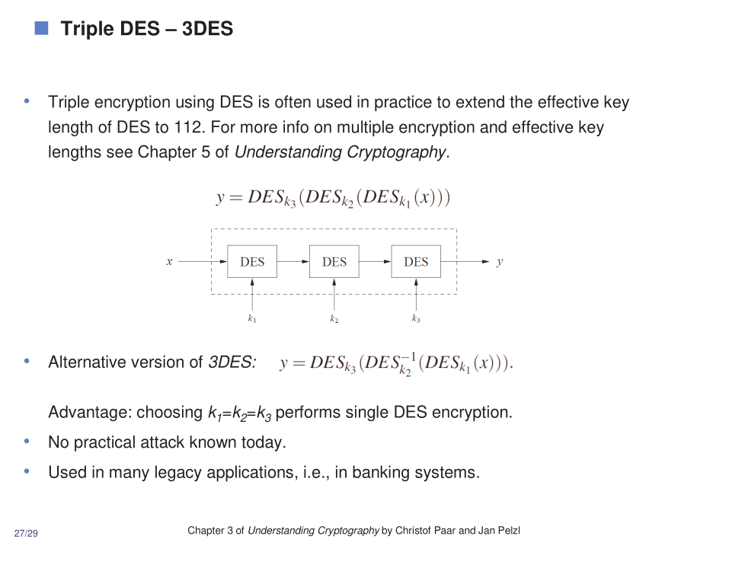

# **How Triple DES (3DES) Works**

Triple DES (3DES) is an encryption algorithm that strengthens the original DES by applying it three times with multiple keys. Here’s a step-by-step explanation of how it works:

## **1. Key Generation**

* Three separate 56-bit keys are created: K1*K*1, K2*K*2, and K3*K*3.
* Sometimes, only two keys are used (K1*K*1 and K2*K*2), with K3=K1*K*3=*K*1 for a slightly lower security level.

## **2. Data Preparation**

* The plaintext message is divided into blocks of 64 bits, just like in regular DES.

## **3. Encryption Process (EDE Mode)**

For each 64-bit block, the following steps are performed:

1. **Encrypt** with K1*K*1:

* The plaintext block is encrypted using DES and the first key K1*K*1.

1. **Decrypt** with K2*K*2:

* The result from step 1 is decrypted using DES and the second key K2*K*2.

1. **Encrypt** with K3*K*3:

* The result from step 2 is encrypted again using DES and the third key K3*K*3.

This sequence is called **Encrypt-Decrypt-Encrypt (EDE)**.

Mathematically:

Ciphertext=EK3(DK2(EK1(Plaintext)))Ciphertext=*EK*3(*DK*2(*EK*1(Plaintext)))

## **4. Decryption Process**

To decrypt, the steps are reversed:

1. **Decrypt** with K3*K*3
2. **Encrypt** with K2*K*2
3. **Decrypt** with K1*K*1

Mathematically:

Plaintext=DK1(EK2(DK3(Ciphertext)))Plaintext=*DK*1(*EK*2(*DK*3(Ciphertext)))

## **5. Why This Sequence?**

* The middle decryption step (with K2*K*2) is used for compatibility with single DES. If all three keys are the same, 3DES acts like regular DES.
* Using three keys increases the effective key length to 168 bits, making brute-force attacks much harder than with single DES.

## **6. Variants of Triple DES**

* **Three-key 3DES:** Uses three independent keys (highest security).
* **Two-key 3DES:** Uses two keys (K1*K*1 and K2*K*2), with K3=K1*K*3=*K*1 (lower security, but still much stronger than DES).

## **7. Advantages and Limitations**

* **Advantages:**
* Much stronger than single DES due to longer key length and triple encryption.
* Backward compatible with DES.
* **Limitations:**
* Slower than DES and modern algorithms like AES.
* Considered legacy; AES is now preferred for new systems.

## **Summary Table: Triple DES Steps**

|  |  |  |
| --- | --- | --- |
| **Step** | **Operation** | **Key Used** |
| 1 | Encrypt | K1*K*1 |
| 2 | Decrypt | K2*K*2 |
| 3 | Encrypt | K3*K*3 |

For decryption, the order is reversed: Decrypt with K3*K*3, Encrypt with K2*K*2, Decrypt with K1*K*1.